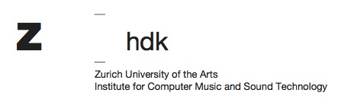

Artists in Residence at ICST – Application Form (Residencies 2024)

Personal Information

Salutation:

First Name:

Last Name:

Date of Birth (dd.mm.yyyy):

Nationalitiy:

Street, House No.:

ZIP:

City:

Country:

Contact

E-Mail:

Phone (private/mobile):

Which residency you apply for?

Residency A: Spatial Sound Synthesis

Residency B: Tempo Polyphony
Please note: Since Residency B entails several trips to Zurich, application is limited to candidates who will be arriving from within Europe.

Residency C: Moving Loudspeakers
Please note: Since Residency C entails several trips to Zurich, application is limited to candidates who will be arriving from within Europe.

Residency D: Immersive Arts

Residency E: Acoustic Ecology

Are there times in 2024 during which you are not able to start the residency?

